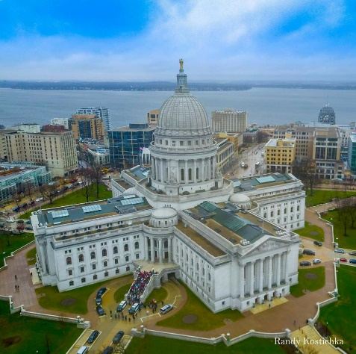
March 26th
2019

WISDOM’s Madison Action Day

A day of collective action with leaders across Wisconsin in

our state capitol.
Join leaders from all parts of Wisconsin who are meeting at the Masonic Temple in Madison for a day of action and movement-building. Madison Action Day is an event that happens every two years leading up to the budget session so we can get our
issues on the minds of legislators while they are making their budget decisions. It is a culmination of what WISDOM and its affiliates are about!

Madison

Madison Masonic Temple
8:30 am to 4 pm

Agenda:

Plenary –“Acting out Our Values”

Lunch – with members of JOB

Action – to be announced

Meeting with legislators –

To find your legislators, go to:

My Vote – select: My Elected Officials – enter your address.

Group Picture – front of the Capitol

______________

COST: $25 / Students $15

(Scholarships available upon request)

______________

Bus: Leaves 7:00 a.m.
Returns 5:30 p.m.
old Elder Beerman Store

Masonic Temple

8:30 – 4:00

Agenda:

Plenary – “Acting out Our Values”

Lunch – with members of JOB

Action – to be announced

Meeting with legislators –

To find your legislators, go to:

My Vote – select: My Elected Officials – enter your address.

Group Picture – front of the Capitol ______

COST: $25 / Students $15

(Scholarships available upon request)

____________

Bus: Leaves 7:00 a.m.
Returns 5:30 p.m.
at old Elder Beer

- - - - - - - - - - - - - - - - - - - - -
Madison Action Day 2019 Registration Form
JOB is excited for you to join us for Madison Action Day 2019. The $25 registration fee includes the bus ride to Madison, breakfast, plenary session, materials, and a box lunch. If you can’t attend but would like to support this event, please consider making a donation for a scholarship.
Send completed form and fee to:
JOB, P.O. Box 1353, Beloit, WI 53512-1353
or give it to any member of JOB

Sign me up for Madison Action Day!

Name: _________________________________________________________________________________
Address: _________________________________________ City, ZIP: ___________________________ Phone: __________________________ Email: _______________________________________________
Registration fee is attached: ______$25 full fee * $ ______donation toward scholarships

PLEASE REGISTER BEFORE MARCH 13

